**Anonymate** 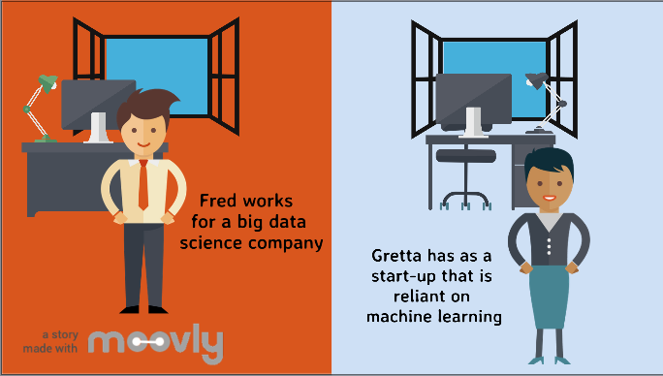

Video script draft ([Moovly](https://www.moovly.com/) Edu Free option)

Link to Video clip: <https://app.hyfy.io/v/abyGbPMdlSn/>

* Fred works for a big data science company
  + Voice Over - “Fred works for a big data science company”
* Gretta has as a start-up that is reliant on machine learning
  + Voice Over - “Gretta has a start-up that is reliant on machine learning”
* Both worry about privacy issues concerning their data (Worried Fred and Gretta)
  + Voice Over - “Both worry about privacy issues concerning their data”
* Fred’s problem - (Worried Fred)
* Fred had collected large sets of data to be used for machine learning.

But there was a data breach and the personal information of his customers was compromised.

* This resulted in a big fine
* Voice Over - “this resulted in a big fine”
* and reduced customer trust.”
  + Voice Over - “and reduced customer trust”
* Gretta learns from the industry history and wants to avoid these issues
  + Voice Over - “Gretta learns from the industry history and wants to avoid these issues”
* “Compliance with GDPR is a MUST!”
  + Voice Over - “Compliance with GDPR is a must!”
* “So she searched the web for the answer”
  + Voice Over - “So she searched the web for the solution…”
* ...and found!
* Our Logo & company name
  + Voice Over - company name and describe the application in 1 sentence - value proposition?
    - **Anonymate - a lightweight, cost-effective tool for data anonymisation; dedicated to protecting the privacy of your users, without affecting data analysis.**
* Competitors
  + Voice Over - “She compared against our competitors…”
* Anonymate is…’Unique, easy to use, cost-effective packages, and helps you to be compliant!’
  + Voice Over - “And found Anonymate is - a unique product, that is easy to use, with Cost-effective packages available. Most importantly helps you to be compliant with regulations.”
* Introduce our product - what it does, how it works - uses advanced mathematics to preserve the data structure without compromising privacy and machine learning performance
* Value proposition - no storage, data is anonymised in the stream (pic taken)
  + Research competitors - unique identifiers
  + Any options out there?
  + Better, faster, easier, cheaper - gets the job done
* Services - packages (i.e. Free(mium), per-user (start ups), enterprise)
* “That’s how Fred and Gretta stay compliant, and anonymise their data”
* “Are you like Fred and Gretta?”
* “Contact us today!” -> ways to find us, and get in contact
* Closing animation